**Software Requirements Specification**

**Team Pontelli**

**The Soft Skills Training System**

**JuSeung Park**

**Flor Lopez**

**Nathan Anderson**

**Jonathan Delira**

**Table of Contents**

1 Introduction 2

1.1 Purpose of Product 2

1.2 Scope of Product 2

1.3 Acronyms, Abbreviations, Definitions 2

1.4 References 2

2 General Description of Product 2

2.1 Context of Product 3

2.2 Product Functions 3

2.3 User Characteristics 3

2.4 Constraints 3

2.5 Assumptions and Dependencies 3

3 Specific Requirements 3

3.1 External Interface Requirements 4

3.1.1 User Interfaces 4

3.1.2 Hardware Interfaces 4

3.1.3 Software Interfaces 4

3.1.4 Communications Interfaces 5

3.2 Domain Model 5

3.3 Functional Requirements 5

3.3.1 Test mode 5

3.3.2 Practice mode 6

3.4 Performance Requirements 6

3.5 Design Constraints 6

3.6 Quality Requirements 6

3.7 Other Requirements 6

4 Appendices 7

4.1 Database Diagram 7

1 Introduction

It has come to the attention of the Bridge of Southern New Mexico that the available workforce is lacking in basic yet vital soft skills. Inquires with employers and research of the subject found that there was no means to train and test the workforce for these job skills. For this reason, they contacted NMSU Computer Science department to request students to develop a software solution.

1.1 Purpose of Product

This training system will help individuals to get and improve their soft skills. As well as be a means of certifying them to be knowledgeable in areas required for a job. This will cultivate the skills necessary for greater employment of the workforce and improve the quality of work done for employers.

1.2 Scope of Product

The Soft Skills Training System will provide an android application and a web page to provide users with textual and visual examples on exercising correct social behavior and interpersonal skills in any given environment. In parallel, work will be dedicated to delivering a subsequent pass/fail evaluation test for certification determination. Final work will be focused on delivering evaluation results, via TCP/IP, to a third party database system, where such results may be retrievable per employer request. The System also will provide businesses the option of creating an specialized test in which they are going to select specific soft skills required for a certain type of employment area.

1.3 Acronyms, Abbreviations, Definitions

* Soft skills: desirable qualities for certain forms of employment that do not depend on acquired knowledge: they include common sense, the ability to deal with people, and a positive flexible attitude.
* X MB: determined amount of megabytes available for responsible use of resources.
* SQL: Structured Query Language.

1.4 References

* Mar, Anna. May, 2013. 87 Soft Skills (The Big List). Retrieved from [http://training.simplicable.com/training/new/87-soft-](http://training.simplicable.com/training/new/87-soft-skills)skills
* soft skills. (n.d.). *Collins English Dictionary - Complete & Unabridged 10th Edition*. Retrieved February 25, 2016 from Dictionary.com website http://dictionary.reference.com/browse/soft-skills
* RecruitLoop. 2016. 75 Behavioural Interview Questions To Select The Best Candidate. Retrieved from http://recruitloop.com/blog/behavioural-interview-questions/

2 General Description of Product

The main focus of the project will be the delivery of content from a central server to an android application. This content of soft skills modules will have two main function, which are train mode and test mode. The additional functionality of the server will be for test setup and the distribution of test requests from the employers to employees, all stored in a SQL database. The server’s web page front will provide access to the administration of accounts and portal to add content to the system.

2.1 Context of Product

The Soft Skills Training System will primarily target people actively seeking jobs with the possibility to expand into high-school and college students that are ready to transition into the workforce. The application of the system will be suitable for devices running android system, while the web page will be compatible with any web browser running in desktop computers or laptops.

2.2 Product Functions

The Soft Skills Training System will allow people to learn various types of soft skills with training mode, and it will allow business people to test prospective employees to see if they are ready for their jobs.

2.3 User Characteristics

The primary users will be prospective employees and employers. These employees may be from high school ages and up. The assumption is that they know how to use an android device and its associated touch screen interface. The employers are expected to be able to use web browser to log into their account and select training questions and identify the workers that they want to request to take their tests.

2.4 Constraints

The Bridge of Southern New Mexico wanted the Soft Skill Training System to be on the android platform. The server and web site will be implemented in JAVA for ease of development and testing. Since android devices have different hardware capacities the application will have a limit on its resource consumption.

2.5 Assumptions and Dependencies

There will be applicable training and testing questions for prospective jobs. The one central server will be available for data requests from the application as well as host a website. In order for the server to fulfill its purpose it will need a publicly accessible domain name and implement a database to manage information.

3 Specific Requirements

The Soft Skills Training System must provide users with a dynamic environment through an android application for testing and training in soft skills and a web page for administration. The testing mode will require the user to register to keep a record. After a test is taken it should provide a clear result of pass or fail. If a test is passed test then provide the user with a certification document. Also, the system must save in a database the pass or fail result, activity timestamps, and user information for the test originator to check the validity and integrity of the test. The practice mode of the system should give users access to all questions of each category enabling them to learn the needed soft skills. Other function that the system should provide is for employers/businesses to register and create and specialized test including the soft skills that are the most needed in that area.

3.1 External Interface Requirements

The Soft Skills Training System is a user based project, so the user interface will be crucial. The user interface will include help on how to navigate the program and the web site. The other interfaces will be done implementing standard frameworks in order to insure reliability.

3.1.1 User Interfaces

The employers and prospective employees will be using the system in different ways. The prospective employees will be using the app for both training and testing. However, the testing functionality requires users to get authentication information from an employer first. The employer will navigate a website login page and perform test setup.

In the app, the user must be able to run either training or testing, and they will bring up training modules where the user has to answer. The testing and training will be similar except the testing will have time limits and will not tell the right answer right away.

The web site will be available for the employers only, and they will be able to look up if their prospective employee has passed the test. They will also be able to see the test database to pick the right test for their company.

3.1.2 Hardware Interfaces

The application will be developed for android platform, and an android device will be the only way to use the application. The web site will not have any designated hardware. Hardware will interface in the standard way for the respective systems.

3.1.3 Software Interfaces

The application and the web site will be internally connected with standard java objects and methods to perform the necessary functionality of the system. The web server will have web sockets for TCP/IP as well as method calls to the SQL database.

3.1.4 Communications Interfaces

The communication of all the separate parts will be done with the internet infrastructure. Mobile devices may link through wifi or mobile broadband. The use of Java frameworks will abstract away the details of inter device communication.

3.2 Domain Model

The system will be composed of a web server and android application having to two modes of operation, test and training, The android application will give a certification if the test was passed. The test mode will require the registration of the user to keep a record the result of the test and give it to an employer in order to check the result of the test. The system also is going to allow businesses to register and create a specific test for the soft skills that are important for a specific work environment.

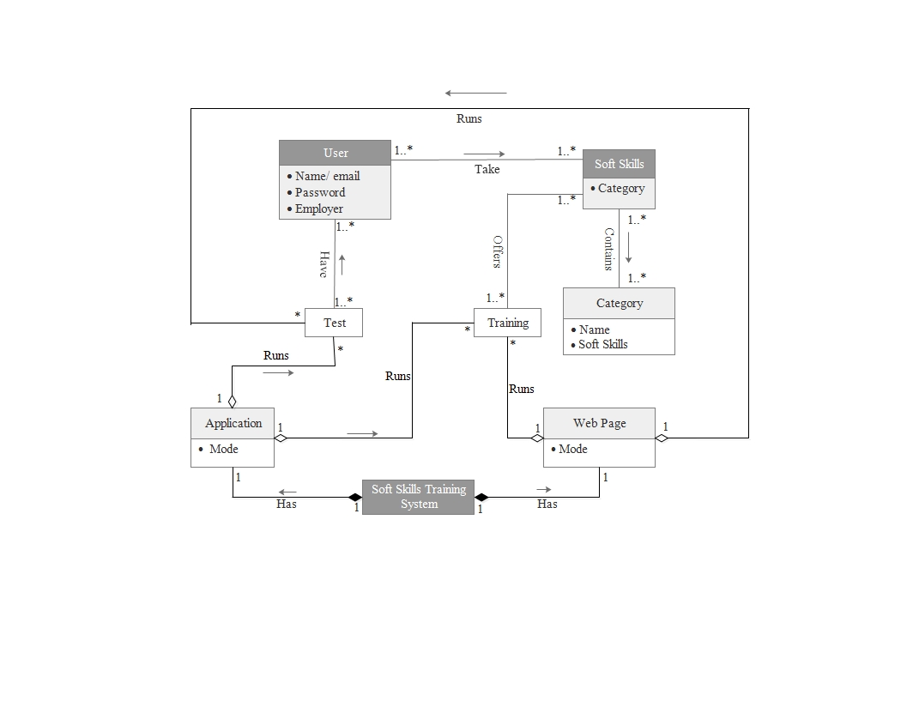

3.3 Functional Requirements

The application as well as the web page of the system should provide the following services:

3.3.1 Test mode

* Common users
* Display the login/signin form.
* If the user is not registered, prompt user to a register form.
* Once the user is register, give access to the different soft skills categories.
* Display videos and questions of the test.
* If the test is passed provide a certification document.
* Employer/Business users
* Prompt the user to a new account form.
* Once the user is register, allow the selection of the required soft skills for that laboral area.
* Create the specialized test.
* Provide a username and password.

3.3.2 Practice mode

* Prompt users to a menu of soft skills categories.
* Once selected, provide videos and questions.
* If a question is answer wrong show the correct answer.

3.4 Performance Requirements

* The system should provide a dynamic content for the user.
* The amount of memory used by the application for module storage will be limited to X MB for responsible use of the available resources.
* Each time the test is run the questions should be randomly presented.
* Randomly display security questions so the system can verify that it is the correct person taking the test.

3.5 Design Constraints

The system shall be designed with proven frameworks and software techniques. There will be modularly system and in the training content to allow for continued development and easy deployment. Standardized templates will be set up for the display of test questions and the timeline layout of modules.

3.6 Quality Requirements

The system shall function reliably and be developed in a manner that allows for easy troubleshooting of faults with ongoing development.

3.7 Other Requirements

For the completion of the project the system will be deployed on NMSU hardware. The intellectual property rights will be worked out between the NMSU Intellectual property department and The Bridge of Southern New Mexico.

4 Appendices

**4.1 Database Diagram**

In the next diagram can be seen the tables that are going to handle the required information in the Soft Skills Training System:

***Table descriptions***

* The *User table* will contain all the information that is required about the person who is going to register such as identification number (IDUser), first and last name (FName and LName, respectively), birthdate to prove that the applicant is high-school aged, social security number for security reasons, and a username and a password as well as the identification number of the business (IDBusiness) in case that the user be requested to take an specialized test.
* The *Business table* is the other type of user of the system, it will handle the information related to the business such as identification number (IDBusiness), name of business (Name), the type of enterprise and its field, a username and password, and the identification number of the specialized test the business created (IDSpecTest).
* The *Test table* is responsible to handle all the information related to the test like test number (IDTest), the question that it contains (IDQuestion), result and the identification number of the user to know who took the test.
* The *SpecTest table* is the other type of test that the system will handle it will contain the information about the test created for each business. The information is identification number of the test (IDSpecTest), name of the test (Name), the identification number of the soft skills and subcategories that the business want to test (IDSoftSkill and IDSubCat, respectively) and the identification number of the question (IDQuestion).
* The *Question table* will manage information such as number identification of the question (IDQuestion), the description of the question (Question) and the answer (Answer), as well as the number identification of the soft skill and the subcategory to which it belongs (IDSoftSkill and IDSubCat, respectively).
* The *Soft_Skill table*  will have the identification number of each category (IDSoftSkill) and the name of the category (Category) such as communication skills, leadership, interpersonal skills, etc.
* The *Sub_Cat table* will contain the identification number (IDSubCat), name (Name), and category to which it belongs (IDSoftSkill).

***Table relations***

* Many *users* can take the same type *test*.
* Many *users* can take the same *specialized test*.
* One or more *users* can belong to one *business*.
* Many *tests* can have many *questions.*
* A *specialized test* can have many *questions.*
* One *soft skill* can have many *questions.*
* One *soft skill* can have many *subcategories.*
* One *subcategory* can have many *questions.*
* One *business* can create one *specialized test.*

